**11.6.1 Is Bigger Smarter?**

Code:

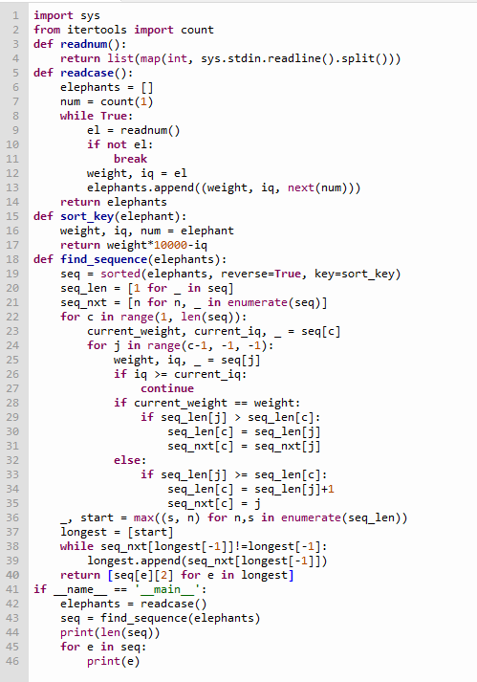

**Output:  
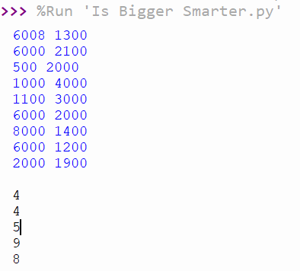**

**11.6.2 Distinct Subsequences**

**Code:**

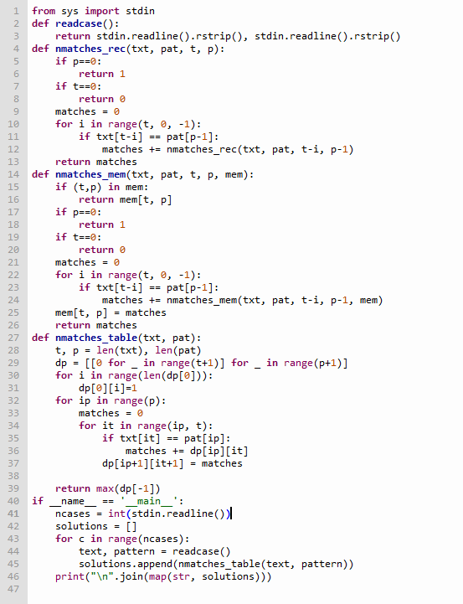

**Output:**

